**Cohort Identification for Place Development Programme**

**Aging Well**

### 1. **Background**

The Place Development Programme is a national programme to accelerate development of thriving place-based approaches to improving population health. The programme is designed for ICS and local Place Leaders including executives, clinical and care leaders, analysts, and digital experts - who represent the Places from primary and secondary care, local government, social and community services, and the voluntary and charity sector. Rooted in action learning, it will equip participating Places with practical tools, techniques and approaches that embed and deliver effective Population Health Management (PHM). The aim of one of these modules in the BNSSG was to create a population that would age well, looking both at short and long-term interventions to improve health.

### 2. The Question

Identify a cohort suitable for intervention in the context of the Place Development Programme: Aging Well program, and provide clinicians involved with key statistics about the population.

### 3. Approach

This project ran over several weeks and followed an iterative approach of decision tree based segmentation, followed by clinician and GP feedback. Initially the elderly (50+) population was segmented using decision trees targeting secondary non-elective costs (which was joined as a new field to the standard data used by the ExploreR, and the tool was refreshed), the segments of which were then summarised by clinical condition prevalence and costs. These outputs were reviewed by the healthcare team on the project, and based on their feedback the initial analysis dataset was modified, and the process repeated. This continuously restricted the subset of the population potentially suitable for this intervention. After several of these feedback cycles, approximately 1920 patients were identified by the healthcare team as a suitable cohort for this intervention.

Figure 1 Decision tree of population segmentation targeting secondary non-elective spend.

Figure 2 Table summarising key characteristics of segments identified by decision tree

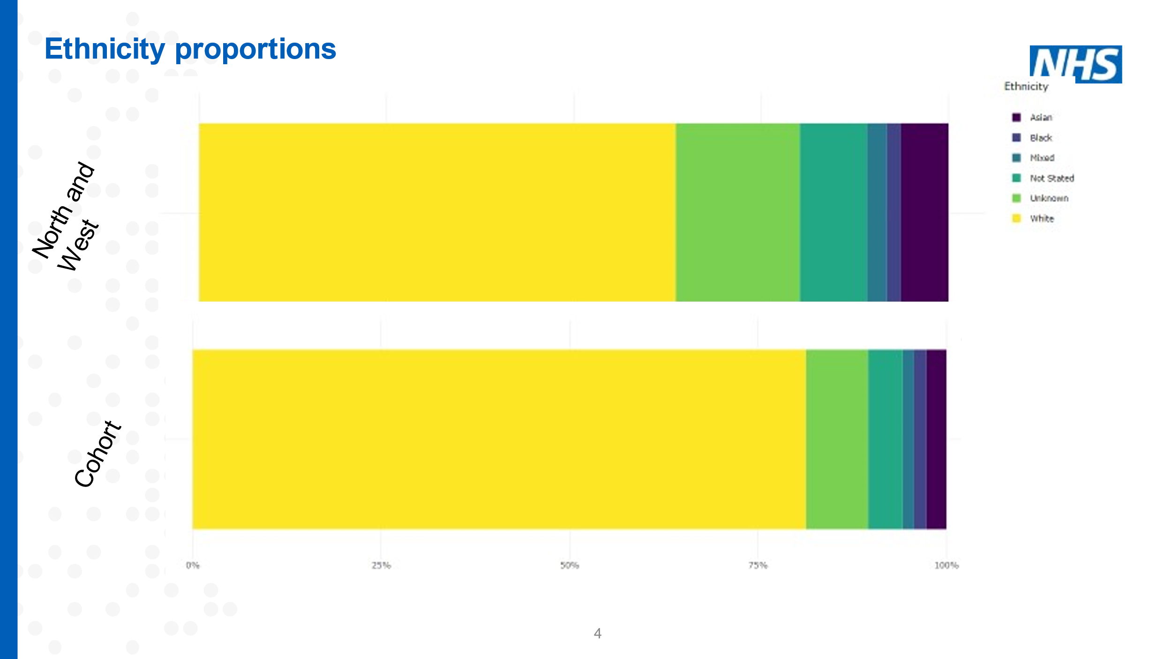

Figure 3 Comparison of final 1920 patients cohort against rest of the population by ethnicity

### 4. Results

This work identified a cohort to target during the Aging Well programme. In addition to the cohort, it also identified some key clinical numbers, and prompted discussion among the clinical leads on how whether there was value in handling dementia patients separately, as well as around potential short or long term interventions to put into place.

### 5. Outcome

This project is ongoing, with outcomes expected over the long term once the suitable intervention has been designed and deployed.